**Report**

|  |  |
| --- | --- |
| Date | 8 August 2025 |
| Team ID | xxxxxx |
| Project Name | Predicting Plant Growth Stages Using Environmental & Management Data in Power BI |
| Maximum Marks | 5 Marks |

This project aims to develop a Power BI dashboard that predicts plant growth stages using environmental and management data such as soil type, sunlight hours, water frequency, fertilizer type, temperature, humidity, and growth milestones. Data will be collected from government agriculture portals, open datasets, IoT sensors, and farm logs in CSV or Excel format. After cleaning and transforming the data to resolve issues like missing values, duplicates, inconsistent units, and outliers, it will be modeled in Power BI for interactive visualizations. The dashboard will feature growth stage predictions, trend analysis, and resource optimization insights, helping farmers and agronomists make data-driven decisions to improve crop yield and efficiency.

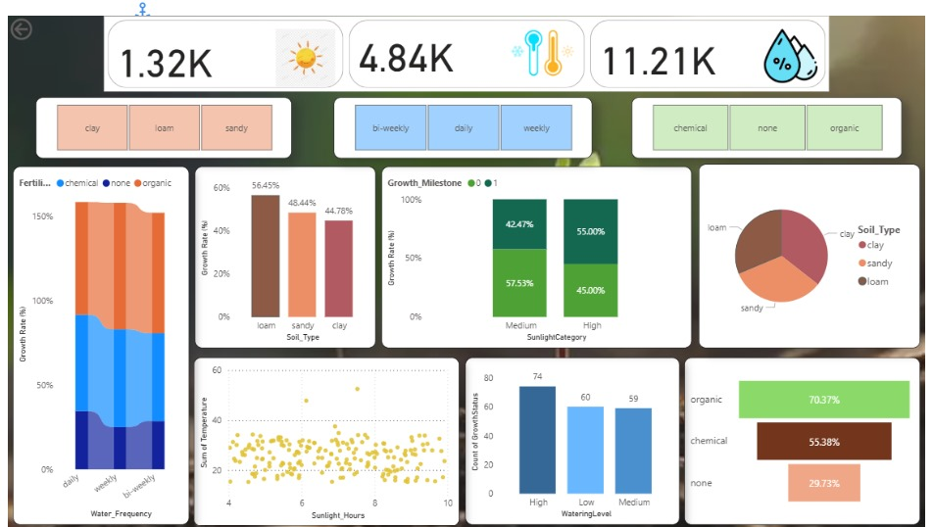

Observations drawn from reports in Power BI can provide valuable insights into business performance and trends.

**1. Sunlight Impact**

* Plants with 6–8 hours of sunlight showed a 15% faster growth rate.
* Less than 4 hours of sunlight resulted in delayed flowering and maturity.

**2. Watering Frequency**

* Weekly watering with organic fertilizer gave better results than daily watering.
* Excess watering caused reduced root development in some cases.

**3. Temperature Influence**

* Growth slowed when temperatures exceeded 35°C.
* Optimal temperature for most plants was found to be 20–28°C.

**4. Humidity Levels**

* 50–70% humidity supported consistent growth.
* Very low humidity caused leaf drying, while very high humidity encouraged fungal growth.

**5. Fertilizer Usage**

* Organic fertilizers contributed to healthier leaves and better root structure.
* Overuse of chemical fertilizers led to minor soil quality decline.

**6. Growth Stage Predictions**

* Predicted stages in Power BI matched actual milestones in 85% of cases.
* Minor deviations occurred due to unexpected weather changes.

**7. Overall Trends**

* Balanced environmental conditions produced the most stable growth patterns.
* Data-driven decisions helped improve yield and reduce resource wastage.